|  |
| --- |
| AIC, MATHEMATICS LEARNING AREA  **YEAR 12 MATHEMATICS APPLICATIONS – UNIT 3**  **Assessment Type: Response - 6%**  **TASK 1 - TEST 1 –** **Term 4, Week 9**  **CALCULATOR-FREE SECTION**  **Syllabus Content:** 3.1.1 – 3.1.9  Bivariate data analysis: Identifying and describing associations, fitting a linear model to numerical data, association and causation |

Student Name: __________________________________________

ID: _______ Date: _______

**TIME ALLOWED: 50 minutes** under test conditions

**MATERIAL REQUIRED / RECOMMENDED FOR THIS PAPER:**

*TO BE PROVIDED BY THE SUPERVISOR*

Question/answer booklet.

*TO BE PROVIDED BY THE CANDIDATE*

*Standard Items:* pens, pencils, pencil sharpener, highlighter, eraser, ruler.

**IMPORTANT NOTE TO CANDIDATES**

No other items may be taken into the examination room. It is **your** responsibility to ensure that you do not have any unauthorised notes or other items of a non-personal nature in the examination room. If you have any unauthorised material with you, hand it to the supervisor **before** reading any further.

**Structure of this paper**

|  |  |  |  |  |
| --- | --- | --- | --- | --- |
| Section | Number of questions available | Number of questions to be attempted | Suggested working time (minutes) | Marks available |
| **Calculator Free** | **4** | **4** | **20** | **21** |
| **Calculator Assumed** | **3** | **3** | **30** | **24** |
|  | | | **Marks available:** | **/45** |
| **Task Weighting** | 6% |

**Instructions to candidates**

* The rules for the conduct of this examination are detailed in the booklet *WACE* *Examinations*

*Handbook*. Sitting this examination implies that you agree to abide by these rules.

* Answer the questions in the spaces provided.
* Spare answer pages can be used. If you need to use them, indicate in the original answer space where the answer is continued.

Question 1 (6 marks)

A student recorded the time taken and the number of correct answers made when completing nine multiple choice tests, each with $20$ different questions, in the table below.

|  |  |  |  |  |  |  |  |  |  |
| --- | --- | --- | --- | --- | --- | --- | --- | --- | --- |
| **Time, $t$ minutes** | $$11$$ | $$8$$ | $$10$$ | $$9$$ | $$15$$ | $$7$$ | $$4$$ | $$13$$ | $$12$$ |
| **Number correct, $c$** | $$14$$ | $$15$$ | $$17$$ | $$14$$ | $$17$$ | $$12$$ | $$10$$ | $$18$$ | $$16$$ |

(a) Construct a scatterplot of this data on the axes below. (2 marks)

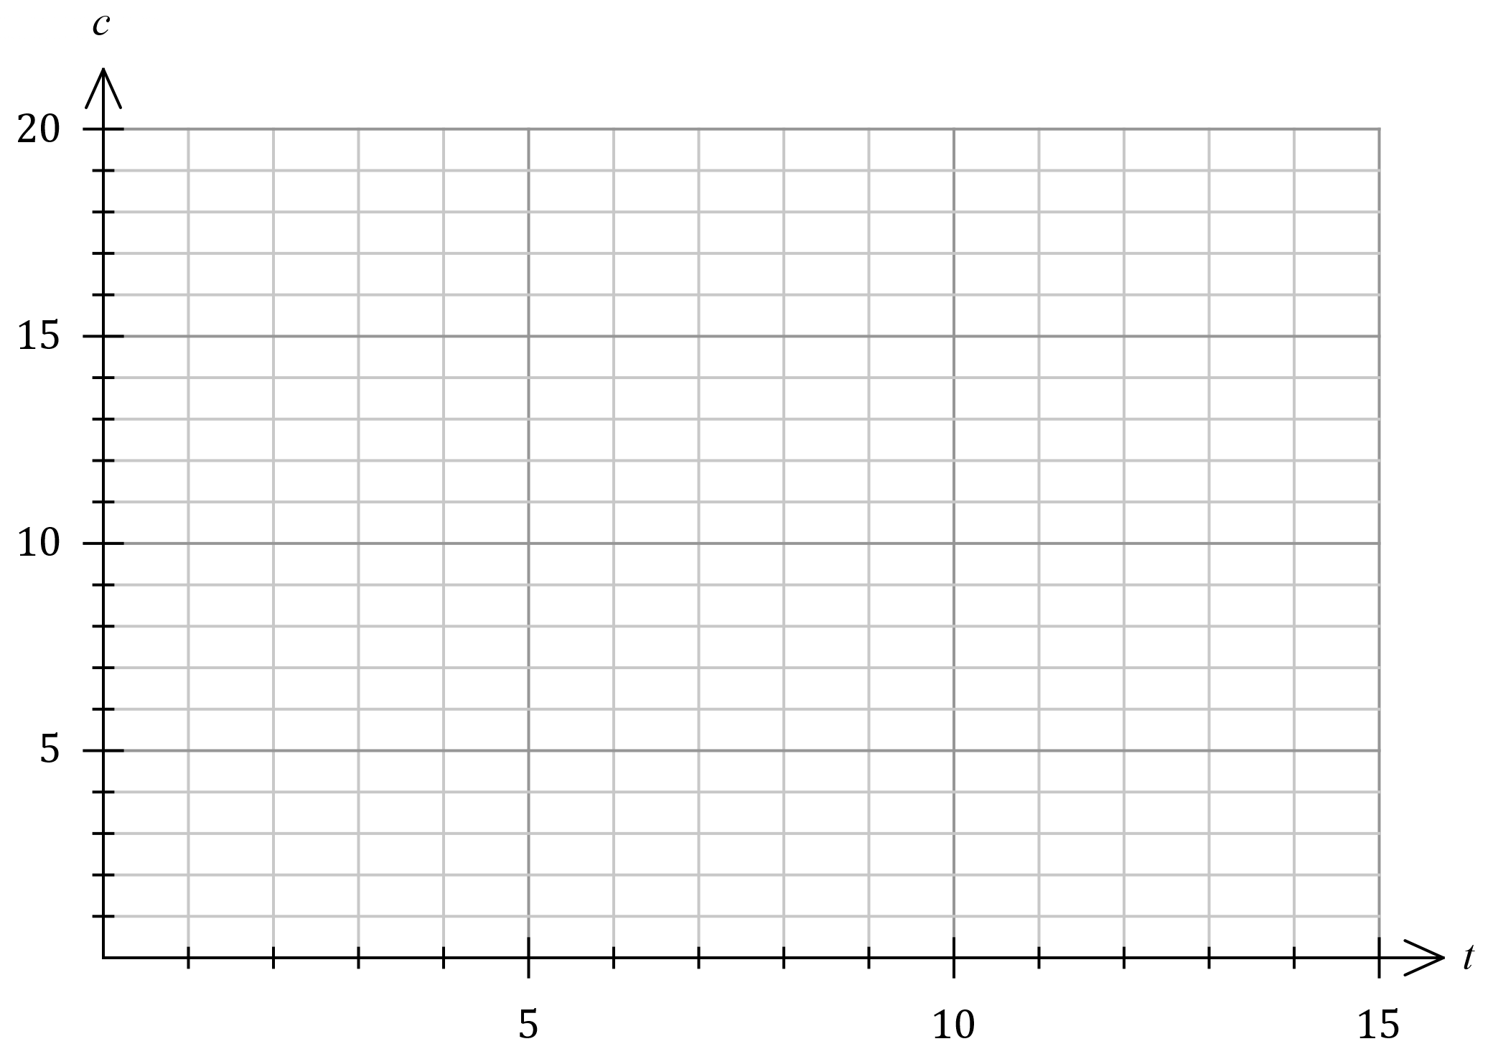

(b) Describe the strength and direction of the association between the two variables.

(2 marks)

(c) The student used the data to conclude that taking more time to answer multiple choice tests   
caused them to answer more questions correctly. Explain whether this conclusion is justified. (2 marks)

Question 2 (7 marks)

Bivariate data analysis of the mass $M$ g, length $L$ mm and width $W$ mm of a large number of snap peas yielded the following correlation coefficients and least-squares lines:

$$r_{WL}=0.8, L=4W+3, r_{ML}=0.7, L=15M+6.$$

(a) Determine the percentage of the variation in the lengths of these snap peas that can be explained by the variation in their masses. (2 marks)

(b) One of the least-squares lines would be better than the other as a predictor for the lengths of these snap peas. Write the equation of the line below and explain your choice.

(2 marks)

(c) Use the equation from part (b) to predict the length of a snap pea that has a mass of $7$ g and a width of $27$ mm. (1 mark)

(d) Explain why it is difficult to comment on the validity of the prediction made in part (c).

(2 marks)

Question 3 (6 marks)

The scatterplot below shows data from $25$ samples drawn from different suburbs in a city. The variables are the percentage of people in each sample who have grey hair ($x$) and who have heart disease ($y$).

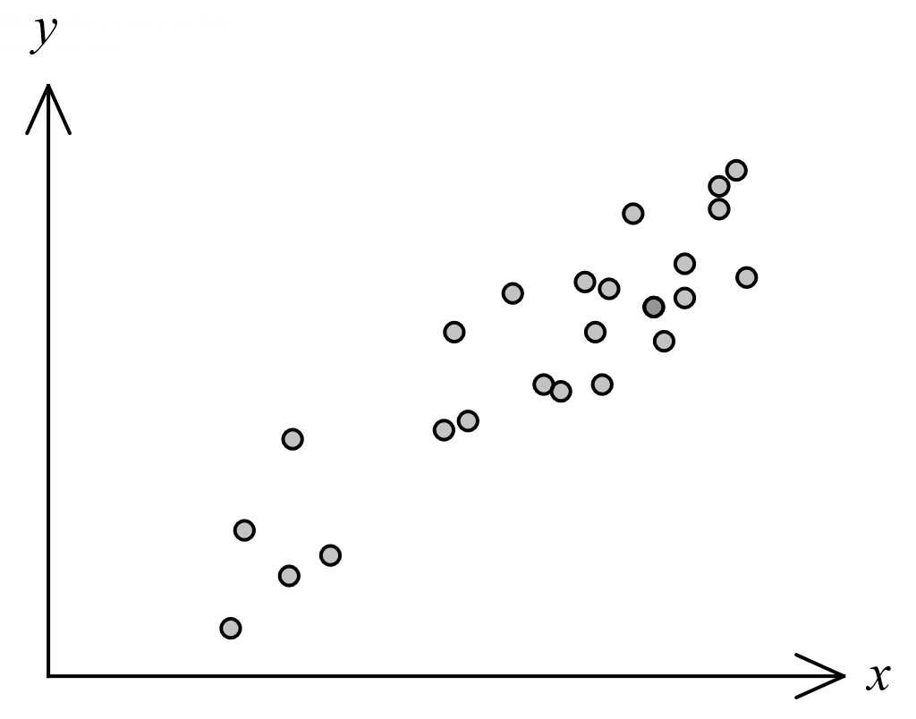

(a) The correlation coefficient $r_{xy}$ for this data is one of $0.9, 0.6, 0.3, -0.3, -0.6, -0.9$.  
State $r_{xy}$ and explain your choice. (2 marks)

(b) The least-squares line for the data is $y=ax+b$, where $a$ and $b$ are constants.

(i) State the name of the response variable for this least-squares line. (1 mark)

(ii) Explain whether the variable $a$ would be a positive or negative number. (1 mark)

(c) Identify and explain a possible non-causal explanation for the observed association between the variables in this data. (2 marks)

**Question 4 [2 marks]**

For the following set of axes, determine whether the variables have been placed on the correct axis.

(Circle Y for yes and N for no)

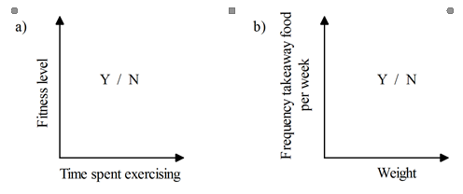

End of Non-Calc Section

|  |
| --- |
| AIC, MATHEMATICS LEARNING AREA  **YEAR 12 MATHEMATICS APPLICATIONS – UNIT 3**  **Assessment Type: Response - 6%**  **TASK 1 - TEST 1 –** **Term 4, Week 9**  **CALCULATOR-ASSUMED SECTION**  **Syllabus Content:** 3.1.1 – 3.1.9  Bivariate data analysis: Identifying and describing associations, fitting a linear model to numerical data, association and causation |

Student Name: __________________________________________

ID: _______ Date: _______

**TIME ALLOWED: 50 minutes** under test conditions

**MATERIAL REQUIRED / RECOMMENDED FOR THIS PAPER:**

*TO BE PROVIDED BY THE SUPERVISOR*

Question/answer booklet.

*TO BE PROVIDED BY THE CANDIDATE*

*Standard Items:* pens, pencils, pencil sharpener, highlighter, eraser, calculator, ruler.

**IMPORTANT NOTE TO CANDIDATES**

No other items may be taken into the examination room. It is **your** responsibility to ensure that you do not have any unauthorised notes or other items of a non-personal nature in the examination room. If you have any unauthorised material with you, hand it to the supervisor **before** reading any further.

**Structure of this paper**

|  |  |  |  |  |
| --- | --- | --- | --- | --- |
| Section | Number of questions available | Number of questions to be attempted | Suggested working time (minutes) | Marks available |
| **Calculator Free** | **4** | **4** | **20** | **21** |
| **Calculator Assumed** | **3** | **3** | **30** | **24** |
|  | | | **Marks available:** | **/45** |
| **Task Weighting** | 6% |

**Instructions to candidates**

* The rules for the conduct of this examination are detailed in the booklet *WACE* *Examinations*

*Handbook*. Sitting this examination implies that you agree to abide by these rules.

* Answer the questions in the spaces provided.
* Spare answer pages can be used. If you need to use them, indicate in the original answer space where the answer is continued.

Question 5 (8 marks)

The following table shows the compressive strength, in megapascals, achieved by concrete after one week for different water-cement ratios, as a percentage, used in its mixture.

|  |  |  |  |  |  |  |  |
| --- | --- | --- | --- | --- | --- | --- | --- |
| **Water-cement ratio $R, \%$** | $$40$$ | $$43$$ | $$46$$ | $$49$$ | $$52$$ | $$57$$ | $$61$$ |
| **Strength $S$, MPa** | $$27.6$$ | $$28.1$$ | $$26.3$$ | $$25.1$$ | $$25.1$$ | $$22.6$$ | $$20.3$$ |

(a) Determine the equation of the least-squares line for the data, with ratio $R$ as the explanatory variable. (2 marks)

(b) In the context of the question, interpret the slope of the least-squares line in part (a).

(2 marks)

(c) State the coefficient of determination and use it to assess the strength of the linear association. (2 marks)

(d) Predict the value of the strength $S$ when the water-cement ratio is $55\%$ and discuss the validity of this prediction. (2 marks)

Question 6 (8 marks)

Participants at a conference were categorised by district they worked in and main area of interest. The table below shows the number of participants in these categories.

|  |  |  |  |  |
| --- | --- | --- | --- | --- |
|  |  | Main area of interest | | |
|  |  | **Technology** | **Science** | **Engineering** |
| District | **Metropolitan** | $$36$$ | $$31$$ | $$19$$ |
| **Regional** | $$52$$ | $$66$$ | $$36$$ |

(a) Determine what percentage of participants

(i) had engineering as their main area of interest. (2 marks)

(ii) worked in the metropolitan district. (1 mark)

(b) Use the above table to complete the following table of row percentages, rounding entries to the nearest whole number. (3 marks)

|  |  |  |  |
| --- | --- | --- | --- |
| (%) | **Technology** | **Science** | **Engineering** |
| **Metropolitan** |  |  |  |
| **Regional** |  |  |  |

(c) Explain whether the percentaged table above suggest the presence of an association between district worked in and main area of interest for the participants. (2 marks)

Question 7 (8 marks)

The linear model fitted to a data set had equation $\hat{y}=15.65x-52.5$. The correlation coefficient between the variables was $r_{xy}=0.986$. The residual plot for the linear model is shown below.

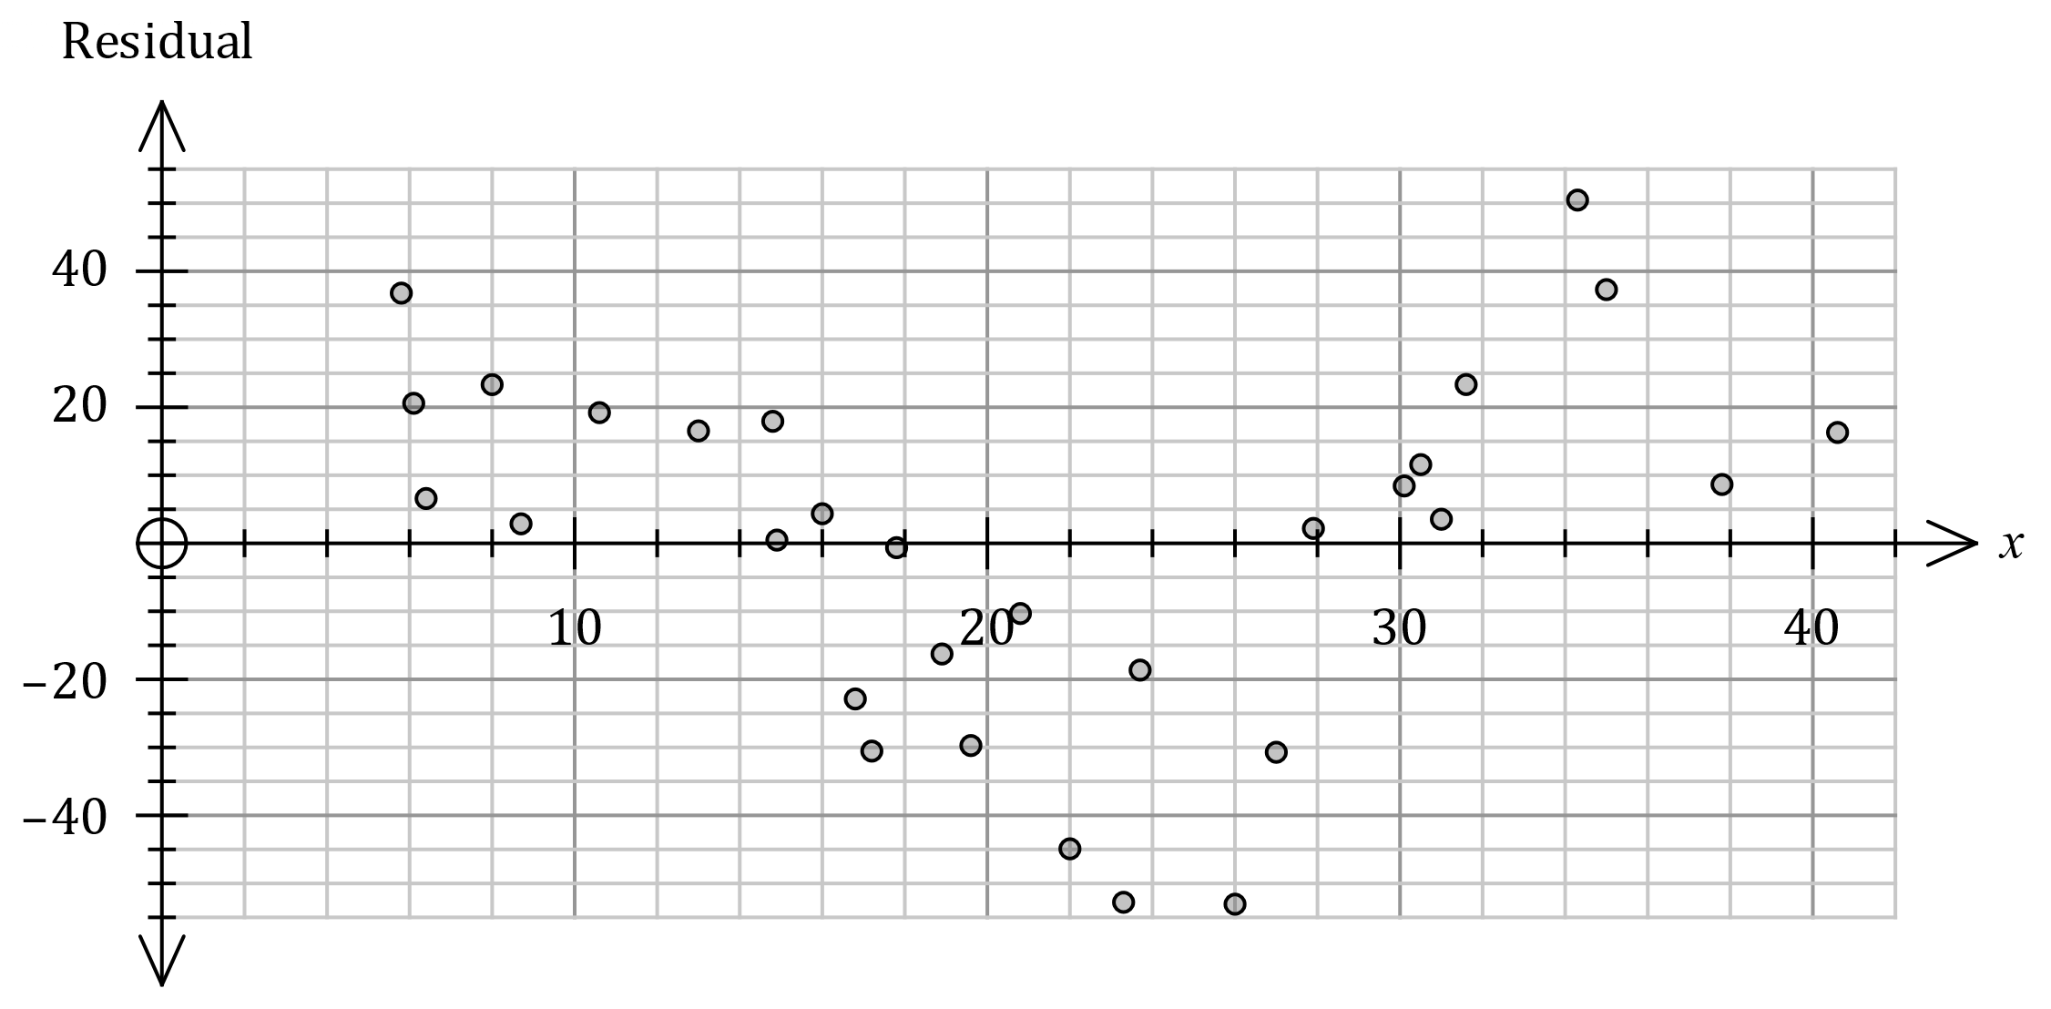

(a) The residual for the data point $(39, 596)$ is not shown. Determine the residual for this point and add it to the residual plot. (3 marks)

(b) Use the residual plot to assess the appropriateness of fitting a linear model to the data.

(2 marks)

(c) The point shown on the plot above with a residual of $-44.8$ was derived from the data point $x=a, y=b$. Determine the value of $a$ and the value of $b$. (3 marks)

**End of test questions**

**EXTRA WORKING PAGE:**